**OSH Authorities – Latvia**

Source: <https://oshwiki.eu/wiki/OSH_systems_at_national_level_-_Latvia>

* OSH Infrastructure

Scheme:

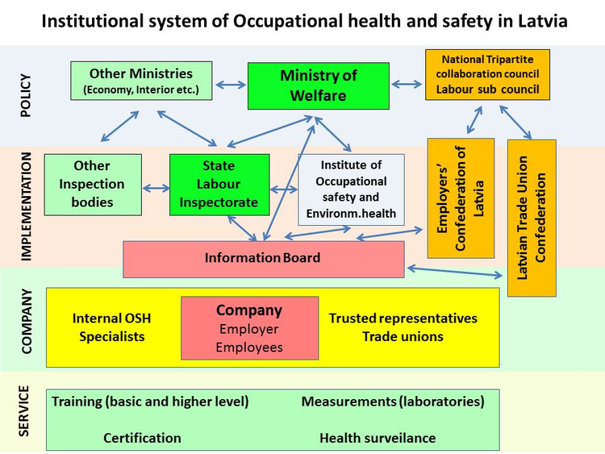

* OSH Authorities

|  |  |
| --- | --- |
| Name of Authority | Ministry of Welfare |
| Link | <http://www.lm.gov.lv/> |
| Short abstract | The main tasks of the Ministry of Welfare in the field of occupational safety and health are following:   * To develop the national policy of OSH and to facilitate its implementation; * To ensure elaboration of national OSH legislation and its compliance with the EU and international legal acts in this field; * To promote creation of safe and harmless working environment, protection of the employees’ right to occupational health and safety and social guarantees; * To facilitate the process of development of OSH administration system; * To promote informing of employers and employees on occupational safety and health issues.   In order to achieve these objectives the Ministry of Welfare is actively working together with several other institutions and social partners. The structure of the Ministry of Welfare is based on several departments of which the Department of Labour Relations and OSH Policy is responsible for OSH area. Several other departments are involved (like Social Insurance Department, Department of Labour Market policy etc.).  The Ministry of Welfare mainly collaborates with all the institutions under its supervision and authority, including the key institution for supervision and control of the occupational safety and health protection system – the State Labour Inspectorate. The Ministry also collaborates with social partners like the Latvian Trade Union Confederation and the Employers’ Confederation of Latvia. Collaboration is mostly accomplished during the process of elaboration of new OSH legislative acts. Representatives of the social partners are involved in the process as from the initial stages of drafting legislation providing opportunity for their contribution co-ordinate joint activities. The Department of Labour Relations and OSH Policy in collaboration with the State Labour Inspectorate is also responsible for coordination of proposals for the annual preventive action plan funded by the State Social Insurance Agency (Valsts Sociālās apdrošināšanas aģentūra). |
| Link to OSH wiki | <https://oshwiki.eu/wiki/OSH_systems_at_national_level_-_Latvia> |

|  |  |
| --- | --- |
| Name of Authority | State Labour Inspectorate |
| Link | <http://www.vdi.gov.lv/> |
| Short abstract | The State Labour Inspectorate is the key control and supervisory institution in the field of OSH operating under the supervision of the Ministry of Welfare (it is the direct management authority). The legal status, function, tasks and the operational procedure of the State Labour Inspectorate is defined in the State Labour Inspectorate Law adopted on 19 June 2008. The State Labour Inspectorate is the only governmental institution that carries out the implementation of the policy in the field of labour legal relations and occupational safety and health. The State Labour Inspectorate carries out various activities to ensure that the Latvian population are socially and legally protected and could work in a safe working environment.  The State Labour Inspectorate has set following mission - to achieve observation of legislation on labour legal relations and occupational safety and health in Latvia in order to be established and maintained a safe, healthy working environment and proper legal labour relations, thereby reducing the number of occupational patients and victims of the accidents at work.  The State Labour Inspectorate has following main functions:   * Supervise and control observance of the requirements of the regulatory enactments regarding labour legal relationships and OSH. * Control how employers and employees mutually fulfil the obligations set by employment contracts and collective labour agreements. * Provide free consultations to employers and employees on labour legal relations and OSH. |
| Link to OSH wiki | <https://oshwiki.eu/wiki/OSH_systems_at_national_level_-_Latvia> |

* Compensation and insurance bodies

|  |  |
| --- | --- |
| Name of Body | State Social Insurance Agency |
| Link | <http://www.vsaa.lv/> |
| Short abstract | There is only one insurance and compensation body in Latvia as the social insurance system and accident insurance system is state owned. The system is provided by the State Social Insurance Agency working under the supervision of the Ministry of Welfare. The main functions of the State Social Insurance Agency include administration of the special social insurance budgets (including insurance against accidents at work and occupational diseases) and the public social services. The State Social Insurance Agency also provides funding for preventive activities in the field of occupational health and safety. System for insurance against accidents at work and occupational diseases is set by the Law on Compulsory Social Insurance in respect of Accidents at Work and Occupational Diseases. The State Social Insurance Agency is handling the compensation system for occupational accidents and diseases. Generally every employee that is legally employed is insured against occupational accidents and diseases as small part of social tax is paid into special social insurance budget. If there is an occupational accident, it must be properly investigated and registered in the State Labour Inspectorate in accordance with the Cabinet Regulations "Procedures for Investigation and Registration of Accidents at Work". Occupational diseases are recognised and registered by the Centre of Occupational and Radiation Medicine (Aroda un radiācijas medicīnas centrs) in accordance with the Cabinet Regulations "Procedures on Investigation and Registration of Occupational Diseases". |
| Link to OSH wiki | <https://oshwiki.eu/wiki/OSH_systems_at_national_level_-_Latvia> |

* Research Institutes

|  |  |
| --- | --- |
| Name of Institute | Institute of Occupational Safety and Environmental Health of the Riga Stradiņš University |
| Link | <http://www.rsu.lv/ddvvi> |
| Short abstract | The Institute of Occupational Safety and Environmental Health is leading research institution in the field of OSH in Latvia both in terms of experience, projects and publications. The Institute is part of the Riga Stradiņš University, which is not only a research institute but rather a combination of academic, scientific and training institution. The Institute for Occupational Safety and Environmental Health has several functions including training for undergraduate and postgraduate students on topics, concerning occupational health and safety, occupational medicine and environmental health, research and expert services. In the field of OSH research its current activities are mostly targeted to research in effects of well-established OSH risks like welding fumes, noise and vibration and also on new and emerging factors like ultra-fine particles and psychosocial and organizational risks. |
| Link to OSH wiki | <https://oshwiki.eu/wiki/OSH_systems_at_national_level_-_Latvia> |

|  |  |
| --- | --- |
| Name of Institute | Faculty of Chemistry of the Latvian University (Latvijas universitātes Ķīmijas fakultāte) |
| Link | <http://www.lu.lv/fakultates/kf/> |
| Short abstract | Some research activities are also done by the Faculty of Chemistry of the Latvian University (Latvijas universitātes Ķīmijas fakultāte). Their recent research includes studies both in the area of chemical risks but also ergonomic and organizational factors of workplaces. |
| Link to OSH wiki | <https://oshwiki.eu/wiki/OSH_systems_at_national_level_-_Latvia> |

|  |  |
| --- | --- |
| Name of Authority | The Institute of Occupational Safety and Civil Defence under the Faculty of Engineering Economics and Management of the Riga Technical University (Rīgas Tehniskās universitātes Inženierekonomikas fakultātes Darba un civilās aizsardzības institūts) |
| Link | <http://www.rtu.lv/en/content/view/885/1112/lang,en/> |
| Short abstract | The Institute is doing some research in the area of OSH mostly focusing on civil protection and fire safety. |
| Link to OSH wiki | <https://oshwiki.eu/wiki/OSH_systems_at_national_level_-_Latvia> |

* Prevention Services

|  |  |
| --- | --- |
| Name of Service | None |
| Link |  |
| Short abstract | There are no official prevention institutions in the field of OSH in the traditional sense of the word. Currently the only institution that has governmental funding and functions is the Institute for Occupational Safety and Environmental Health (Darba drošības un vides veselības institūts) of the Riga Stradiņš University that is an academic, scientific and training institution. The Institute for Occupational Safety and Environmental Health has several functions including training for undergraduate and postgraduate students on topics, concerning occupational health and safety, occupational medicine and environmental health, research and expert services.  According to the "Law on Compulsory Social Insurance in respect of Accidents at Work and Occupational Diseases" every year 0.5% of the special insurance budget is spent on preventive activities in the field of occupational health and safety. The annual plan is approved by the Information Board of the Latvian Focal point for the European Agency for Safety and Health at Work which consists of competent representatives from the Ministry of Welfare, the State Labour Inspectorate, the Latvian Free Trade Union Federation, the Latvian Employers’ Confederation, as well as the Institute of Occupational Safety and Environmental Health . |
| Link to OSH wiki | <https://oshwiki.eu/wiki/OSH_systems_at_national_level_-_Latvia> |

* Other OSH Services

|  |  |
| --- | --- |
| Name of Association | The Association of Latvian Occupational Physicians (Latvijas arodslimību ārstu biedrība) |
| Link | <http://www.arodslimibas.lv/> |
| Short abstract | The Association is joining more than 400 occupational health and medicine doctors and is responsible for updating training for its members as well as certification and re-certification of occupational health and medicine doctors. |
| Link to OSH wiki | <https://oshwiki.eu/wiki/OSH_systems_at_national_level_-_Latvia> |

|  |  |
| --- | --- |
| Name of Association | The Latvian Association of Occupational Health and Safety Experts (Latvijas darba aizsardzības speciālistu asociācija) |
| Link | <http://www.ldasa.lv/> |
| Short abstract | The Association is joining both basic level and higher-level OSH experts working across various industries. The association is responsible for provision of information to its members and for preparation of test materials for re-certification system of higher-level OSH specialists that are working as so called “competent specialists” in accordance with the Cabinet Regulations "Regulations Regarding the Requirements for Competent Authorities and Competent Specialists in Labour Protection Issues and the Procedures for Evaluating Competence". |
| Link to OSH wiki | <https://oshwiki.eu/wiki/OSH_systems_at_national_level_-_Latvia> |

|  |  |
| --- | --- |
| Name of Association | The Latvian Association of competent institutions in OSH (Darba aizsardzības kompetento institūciju biedrība) |
| Link | <http://dakib.lv/> |
| Short abstract | The Association is joining several companies offering external services in OSH. The main task of the association is to promote business environment in OSH and fire safety, provide awareness raising events for employers in OSH and fire safety and explain legal requirements for members. |
| Link to OSH wiki | <https://oshwiki.eu/wiki/OSH_systems_at_national_level_-_Latvia> |

* Standardization Bodies

|  |  |
| --- | --- |
| Name of Authority | Latvian Standard (Standartizācijas birojs) |
| Link | <http://www.lvs.lv/> |
| Short abstract | The Latvian Standard is one of three independent agencies operating as part of limited liability company the Standardization, Accreditation and Metrology Centre (SIA „Standartizācijas, akreditācijas un metroloģijas centrs”). It works in accordance with the Standardisation Law. It carries out its specific functions that are:   * To organize development of the Latvian national standards in standardization technical committees; * To adapt all the standards published by European standardization bodies and international standards which are essential for the national economy; * To ensure a stock formation of standards and related documents, the stock maintenance and amendment, as well as information dissemination in the field of standardization; * To participate in the work of international and regional standardization bodies. |
| Link to OSH wiki | <https://oshwiki.eu/wiki/OSH_systems_at_national_level_-_Latvia> |